**CI/CD Pipeline using Jenkins and Ansible:**

**Prerequisites:**

* Jenkins is setup and running.
* Ansible is setup and running.
* Publish Over SSH plugin should be installed in Jenkins.

The following set of steps to be performed, to trigger job from Jenkins automatically whenever and configurations or code changes take place in Git. The Job in Jenkins will build and execute respective Ansible playbook to deploy the updated configurations or code.

* Create a new item in Jenkins under Freestyle project.
* Under source Code management, select Git and provide the repository URL of Git.

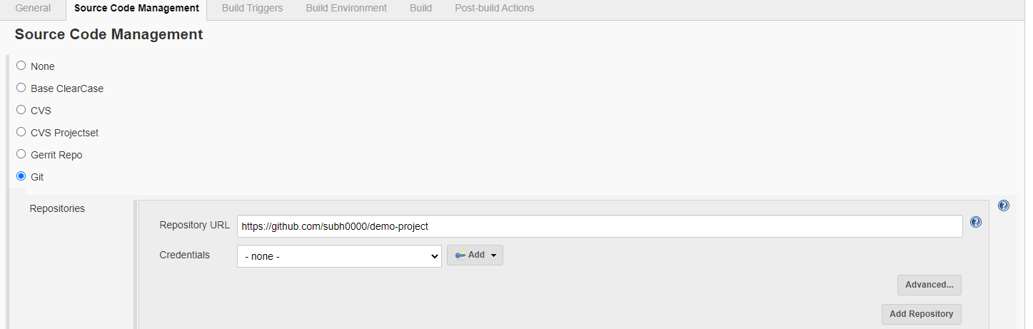

* Set build triggers to every 15minutes as of now.

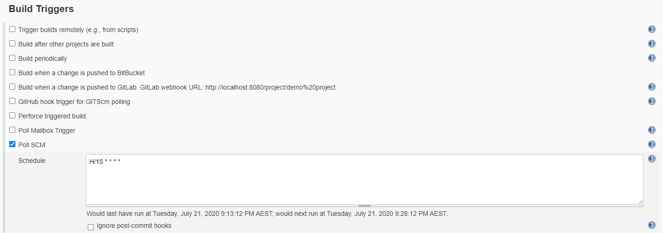

* Set the Build section. Here Ansible server details and other configuration parameters to be provided.
* Add the Ansible server under ssh host. Click on Jenkins 🡪Manage Jenkins 🡪Configure Systems 🡪ssh 🡪click on add.

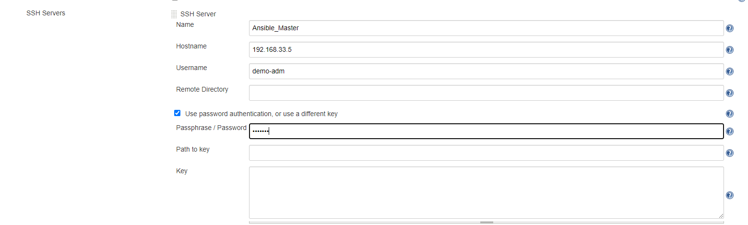

* Test the connection, if successful then apply and save.

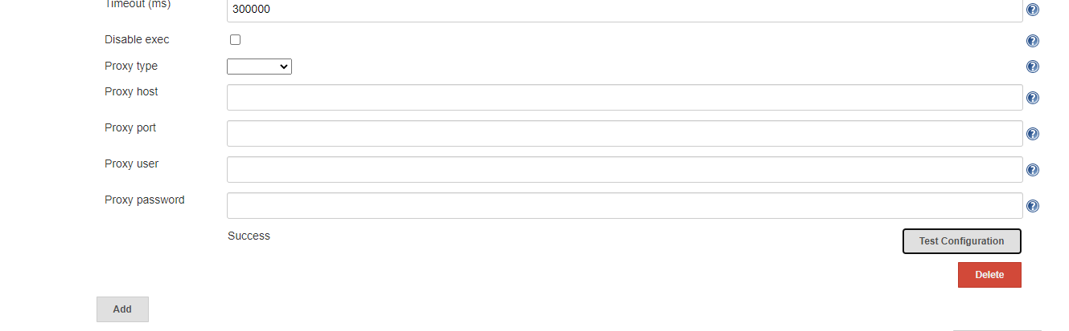

* Click on demo project 🡪Configure 🡪Post build Action.

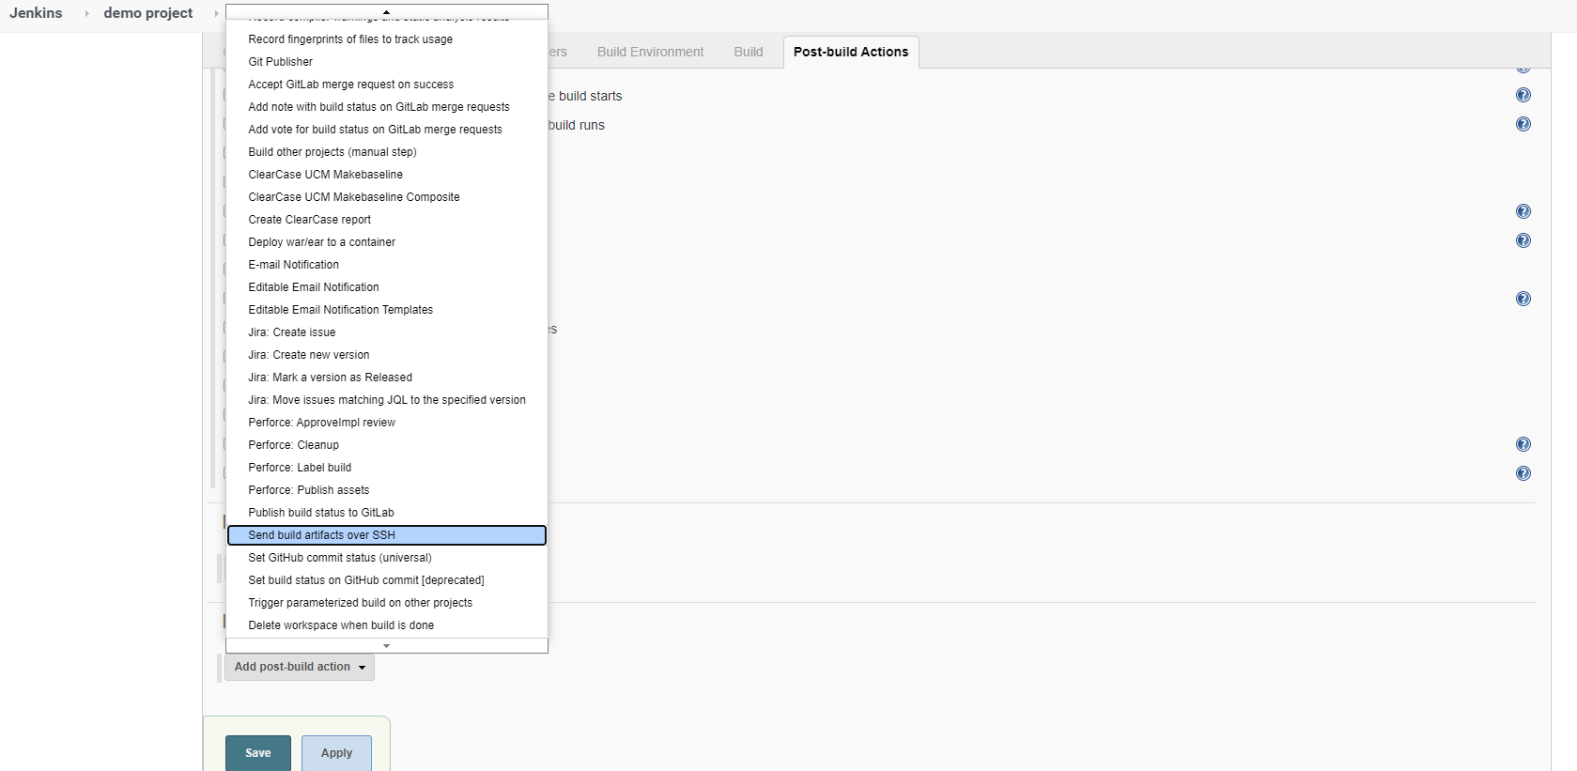

* Add one more post build step to execute the Ansible playbook.

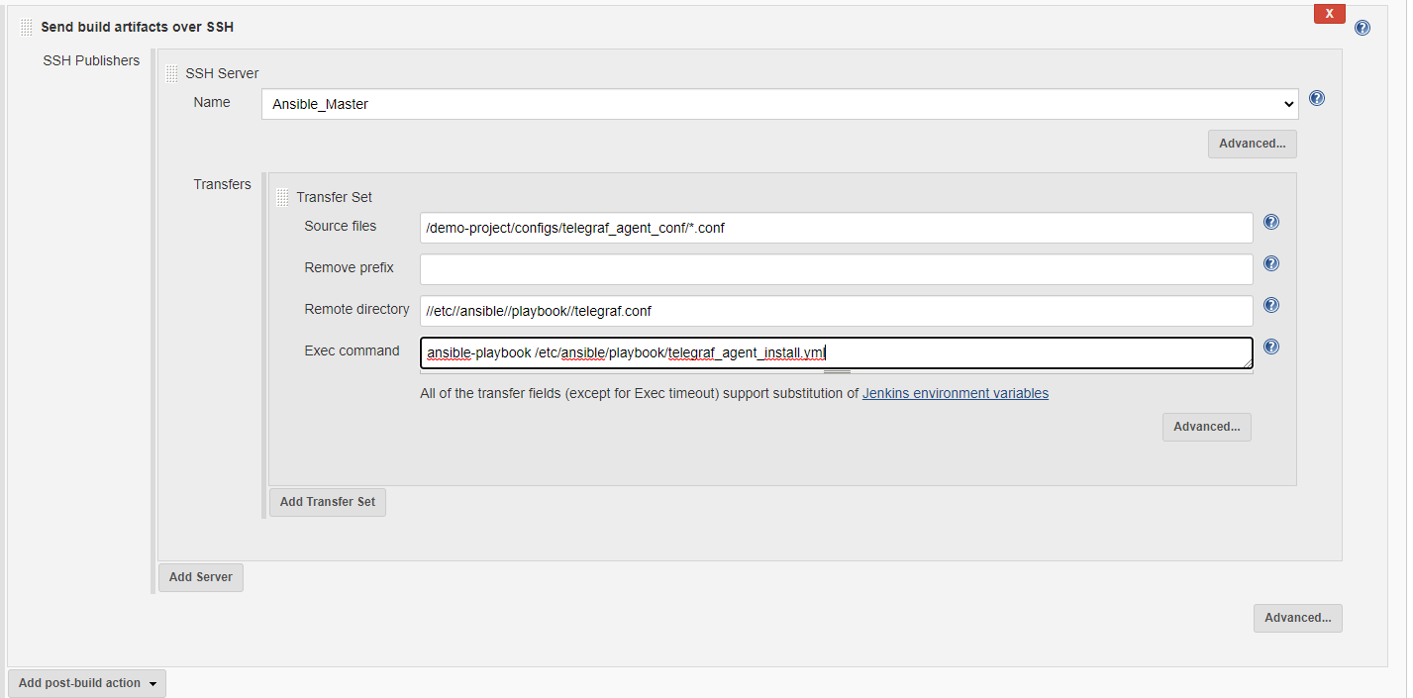

* Go to Jenkins dashboard and build the project and capture the output. It will successfully install, configure, enable on-boot of telegraf agent on the remote server.

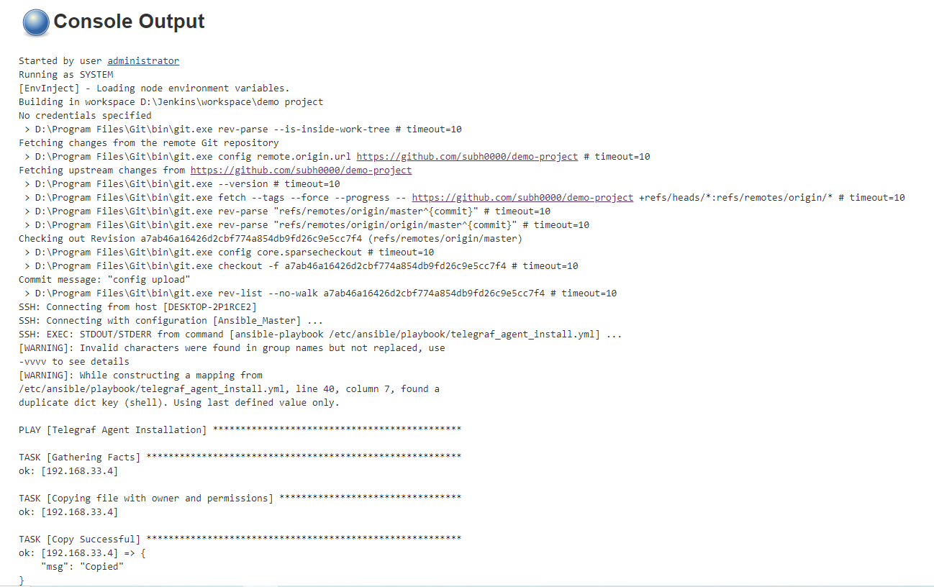

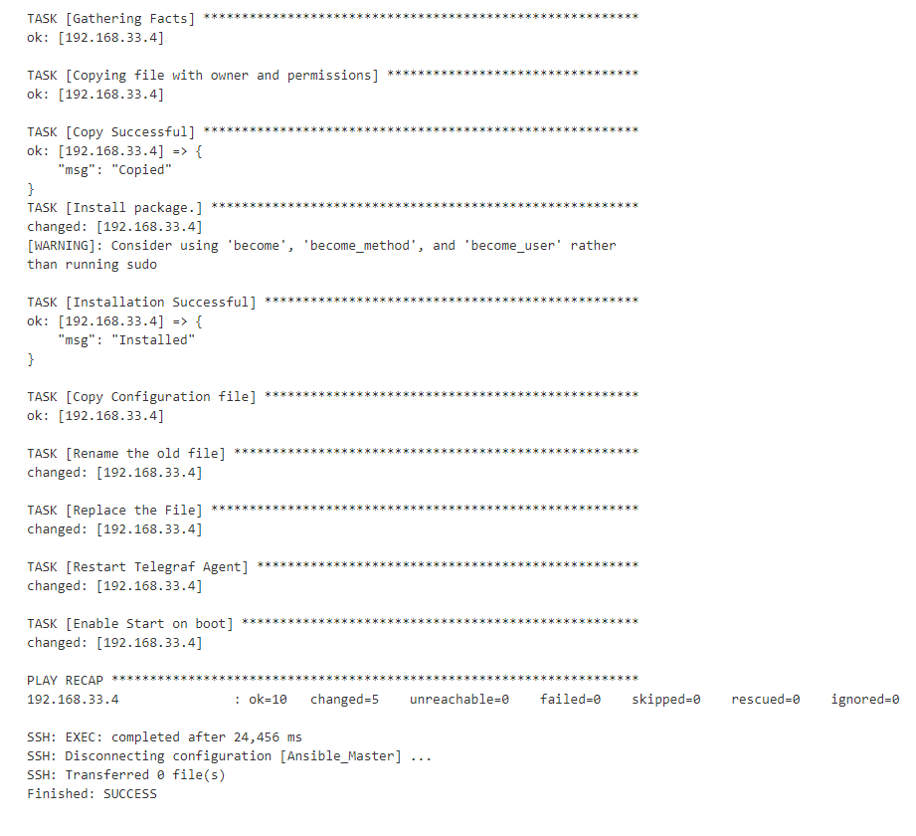

This confirms CI/CD pipeline automation.